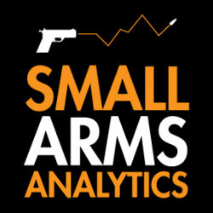
Note to Editors: Small Arms Analytics & Forecasting’s Chief Economist Jurgen Brauer is available for interviews. Contact: jbrauer@SmallArmsAnalytics.com.
For Immediate Release, March 5, 2020
U.S. firearms sales: February 2020 unit sales again increase drastically
(GREENVILLE, SC, USA & HALIFAX, NS, CANADA) – Small Arms Analytics & Forecasting (SAAF) estimates February 2020 U.S. firearms unit sales at 1,357,643 units, a year-over-year increase of 17.3% from February 2019. Likely single handgun sales (793,301) increased year-over-year by 19.5% whereas single long-gun sales (441,516) increased year-over-year by 12.4%. All other likely background check-related sales (122,826) increased year-over-year by 22.1%. This includes so-called “multiple” sales where the allocation between handguns and long-guns cannot be determined from the data record.
SAAF’s firearms unit sales estimates are based on raw data taken from the FBI’s National Instant Criminal Background Check System (NICS), adjusted for checks unlikely to be related to end-user firearms sales. For example, the FBI’s raw numbers (for February, some 2,776,380) cannot be taken at face value as very large numbers of background checks are unrelated to end-user sales. As a case in point, in February the state of Kentucky conducted about 368,000 so-called permit checks and rechecks alone whereas end-user checks at firearms retailers likely amounted to about 30,000 checks. SAAF makes certain other adjustments to the data based on retailer reports and other information; nonetheless, the estimates still likely understate the “true” number of unit sales.
SAAF Chief Economist Jurgen Brauer comments that “it appears as if firearms owners are casting early votes in the upcoming presidential election this year: Unit sales in both, January and February 2020 have been at their highest levels since 2016.”
-30-
Contact: Corinne MacLellan <media@SmallArmsAnalytics.com> +1-902-209-3234.
Chart attached: Approximate United States Firearms Sales (January 2000 to February 2020).
ABOUT Small Arms Analytics & Forecasting:
Small Arms Analytics & Forecasting (SAAF) is a research consultancy focusing on the business & economics of the global small arms and ammunition markets. Politically unaffiliated, SAAF is an independent, evidenced-based resource for industry, advocacy, research, and policymaking alike, as well as for financial analysts and members of the media. Among other services, SAAF produces forecasts of U.S. civilian firearms unit sales, nationwide and for most states. Small Arms AnalyticsSM and Small Arms Analytics & ForecastingSM are legally protected Service Marks of Small Arms Analytics & Forecasting. (Contact sales@SmallArmsAnalytics.com for sales and other information.)

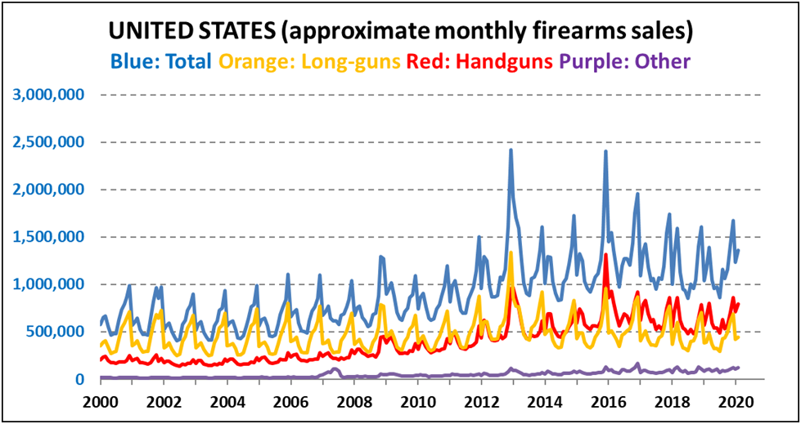© Small Arms Analytics & Forecasting | SmallArmsAnalytics.com

