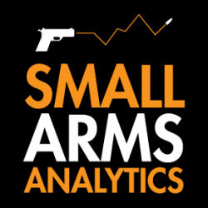
Note to Editors: Small Arms Analytics & Forecasting’s Chief Economist Jurgen Brauer is available for interviews. Contact: jbrauer@SmallArmsAnalytics.com.
For Immediate Release, April 1, 2020
U.S. firearms sales: March 2020 unit sales show anticipated covid-19-related boom
(GREENVILLE, SC, USA & HALIFAX, NS, CANADA) – Small Arms Analytics & Forecasting (SAAF) estimates March 2020 U.S. firearms unit sales at 2,583,238 units, a year-over-year increase of 85.3% from March 2019. Likely single handgun sales (1,534,002) increased year-over-year by 91.1% whereas single long-gun sales (835,663) increased year-over-year by 73.6%. All other likely background check-related sales (213,573) increased year-over-year by 94.0%. This includes so-called “multiple” sales where the allocation between handguns and long-guns cannot be determined from the data record.
SAAF’s firearms unit sales estimates are based on raw data taken from the FBI’s National Instant Criminal Background Check System (NICS), adjusted for checks unlikely to be related to end-user firearms sales. For example, the FBI’s raw numbers (for March, some 3,709,562) cannot be taken at face value as very large numbers of background checks are unrelated to end-user sales. As a case in point, in March the state of Kentucky conducted about 185,000 so-called permit checks and rechecks alone whereas end-user checks at firearms retailers likely amounted to about 53,000 checks. SAAF makes certain other adjustments to the data based on retailer reports and other information; nonetheless, the estimates still likely understate the “true” number of unit sales.
SAAF Chief Economist Jurgen Brauer comments that “as anticipated by general media and within-industry reports, firearms unit sales boomed in March 2020 largely due to the covid-19 health crisis. Much of the industry’s inventory will have been depleted, so that we anticipate that weapons and ammunition prices increased as well. (Small arms price inflation numbers will be reported by the federal government later on.) The spurt in firearms sales in March 2020 was particularly notable for its handgun component: The ratio of handguns to long-guns sold now stands at a record 1.84, the highest ratio since the introduction of the NICS checks in late 1998.”
-30-
Contact: Corinne MacLellan <media@SmallArmsAnalytics.com> +1-902-209-3234.
Chart attached: Approximate United States Firearms Sales (January 2000 to March 2020).
ABOUT Small Arms Analytics & Forecasting:
Small Arms Analytics & Forecasting (SAAF) is a research consultancy focusing on the business & economics of the global small arms and ammunition markets. Politically unaffiliated, SAAF is an independent, evidenced-based resource for industry, advocacy, research, and policymaking alike, as well as for financial analysts and members of the media. Among other services, SAAF produces forecasts of U.S. civilian firearms unit sales, nationwide and for most states. Small Arms AnalyticsSM and Small Arms Analytics & ForecastingSM are legally protected Service Marks of Small Arms Analytics & Forecasting. (Contact sales@SmallArmsAnalytics.com for sales and other information.)

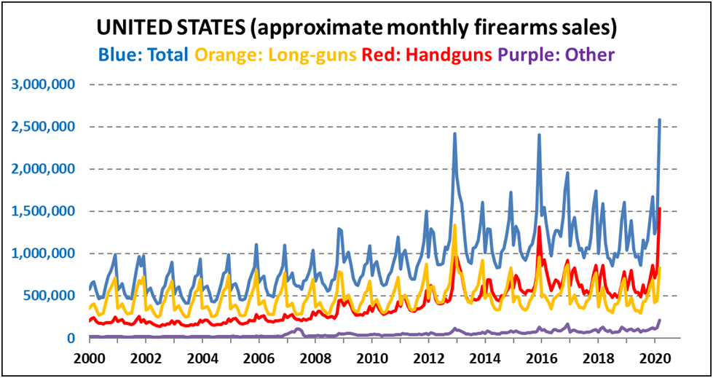© Small Arms Analytics & Forecasting | SmallArmsAnalytics.com

