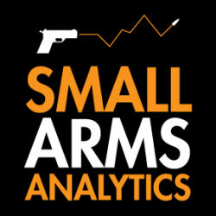
Note to Editors: Small Arms Analytics & Forecasting’s Chief Economist Jurgen Brauer is available for interviews. Contact: jbrauer@SmallArmsAnalytics.com.
For Immediate Release, June 1, 2020
U.S. firearms sales: May 2020 unit sales break records yet again
(GREENVILLE, SC, USA & HALIFAX, NS, CANADA) – Small Arms Analytics & Forecasting (SAAF) estimates May 2020 U.S. firearms unit sales at 1,726,053 units, a year-over-year increase of 80.2% from May 2019. Likely single handgun sales (1,052,723) increased year-over-year by 94.0% whereas single long-gun sales (535,014) increased year-over-year by 66.3%. All other likely background check-related sales (138,316) increased year-over-year by 48.2%. This includes so-called “multiple” sales where the allocation between handguns and long-guns cannot be determined from the data record.
SAAF’s firearms unit sales estimates are based on raw data taken from the FBI’s National Instant Criminal Background Check System (NICS), adjusted for checks unlikely to be related to end-user firearms sales. For example, the FBI’s raw numbers (for May, some 3,066,740) cannot be taken at face value as large numbers of background checks are unrelated to end-user sales. As a case in point, in May the state of Kentucky conducted close to 360,000 so-called permit checks and rechecks alone whereas end-user checks at firearms retailers likely amounted to about 38,000 checks. SAAF makes certain other adjustments to the data based on retailer reports and other information; nonetheless, the estimates still likely understate the “true” number of unit sales.
SAAF Chief Economist Jurgen Brauer comments that “yet again, firearms sales have surged in unprecedented ways. In May 2020, very nearly two handguns were sold for every long-gun, pushing their ratio new record of 1.97. Traditionally, the ratio increases in the first half of the year before dropping off in the second half. Still, the boom in handgun sales has been particularly noticeable in recent months.”
-30-
Contact: Corinne MacLellan <media@SmallArmsAnalytics.com> +1-902-209-3234.
Charts attached:
- Approximate United States Firearms Sales (January 2000 to May 2020).
- Ratio of Handgun to Long-gun Sales in the United States (January 2000 to May 2020).
ABOUT Small Arms Analytics & Forecasting:
Small Arms Analytics & Forecasting (SAAF) is a research consultancy focusing on the business & economics of the global small arms and ammunition markets. Politically unaffiliated, SAAF is an independent, evidenced-based resource for industry, advocacy, research, and policymaking alike, as well as for financial analysts and members of the media. Among other services, SAAF produces forecasts of U.S. civilian firearms unit sales, nationwide and for most states. Small Arms AnalyticsSM and Small Arms Analytics & ForecastingSM are legally protected Service Marks of Small Arms Analytics & Forecasting. (Contact sales@SmallArmsAnalytics.com for sales and other information.)

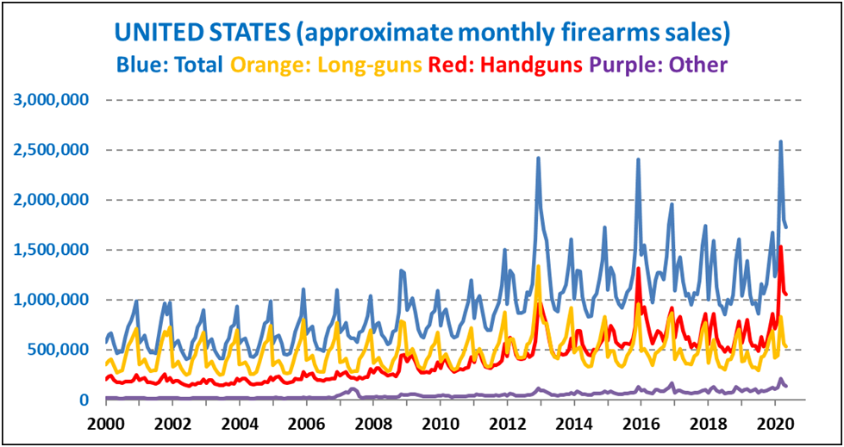© Small Arms Analytics & Forecasting | SmallArmsAnalytics.com
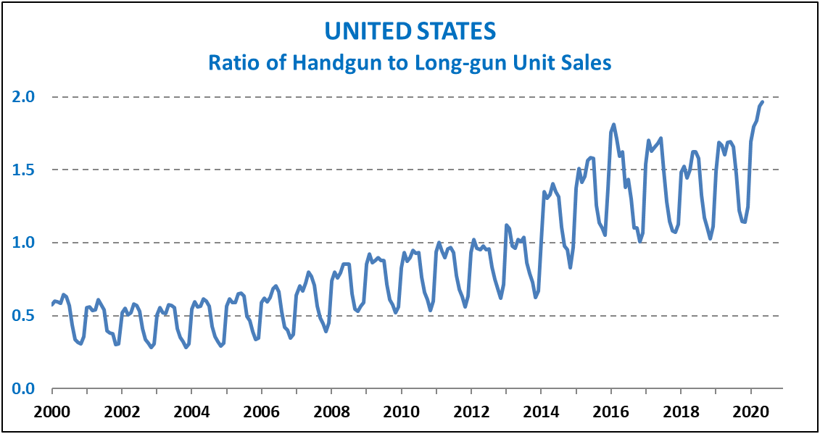
© Small Arms Analytics & Forecasting | SmallArmsAnalytics.com

