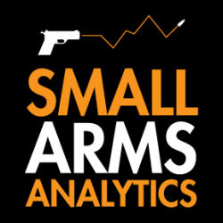
Editors: Small Arms Analytics & Forecasting’s Chief Economist Jurgen Brauer is available for interviews. Contact: jbrauer@SmallArmsAnalytics.com.
For Immediate Release, October 3, 2020
U.S. firearms sales: 2020 year-to-date sales set new high

(GREENVILLE, SC, USA & HALIFAX, NS, CANADA) – Small Arms Analytics & Forecasting (SAAF) estimates September 2020 U.S. firearms unit sales at 1.8 million units, a year-over-year increase of 66% from September 2019. Likely single handgun sales (0.98 million) increased year-over-year by 81% whereas single long-gun sales (0.66 million) increased year-over-year by 51%. All other likely background check-related sales (0.13 million) increased year-over-year by 50%. This includes so-called “multiple” sales where the exact split between handguns and long-guns cannot be determined from the data record.
Detailed data by firearms type and state are available for purchase at https://SmallArmsAnalytics.com/shop/.
SAAF’s firearms unit sales estimates are based on raw data taken from the FBI’s National Instant Criminal Background Check System (NICS), adjusted for checks unlikely to be related to end-user firearms sales. For example, the FBI’s raw numbers (for September, some 2,857,953) cannot be taken at face value as large numbers of background checks are unrelated to end-user sales. As a case in point, in September the state of Illinois conducted about 378,000 so-called permit checks and rechecks alone whereas end-user unit sales at firearms retailers likely amounted to about 49,000. SAAF makes certain other adjustments to the data based on retailer reports and other information; nonetheless, the estimates still likely understate the true number of sales.
SAAF Chief Economist Jurgen Brauer comments that “the 2020 year-to-date sales (January to September) now stand at 16.7 million and thereby exceed the previous annual high (January to December) set in 2016 with 16.6 million units sold. That said, the August and September in 2020 increases are the lowest since March 2020. Handgun sales continue to comfortably outpace long-gun sales.”
-30-
Media contact: Corinne MacLellan <media@SmallArmsAnalytics.com>
Charts attached:
- Approximate United States Firearms Sales (January 2000 to September 2020).
- Unadjusted FBI/NICS raw data versus SAAF-adjusted NICS data (January 2000 to September 2020).
Follow us on Twitter | Instagram | Facebook
ABOUT Small Arms Analytics & Forecasting
Small Arms Analytics & Forecasting (SAAF) is a research consultancy focusing on the business & economics of the global small arms and ammunition markets. Politically unaffiliated, SAAF is an independent, evidenced-based resource for industry, advocacy, research, and policymaking alike, as well as for financial analysts and members of the media. Among other services, SAAF produces forecasts of U.S. civilian firearms unit sales, nationwide and for most states. Small Arms AnalyticsSM and Small Arms Analytics & ForecastingSM are legally protected Service Marks of Small Arms Analytics & Forecasting. (Contact sales@SmallArmsAnalytics.com for sales and other information.)
CHART 1
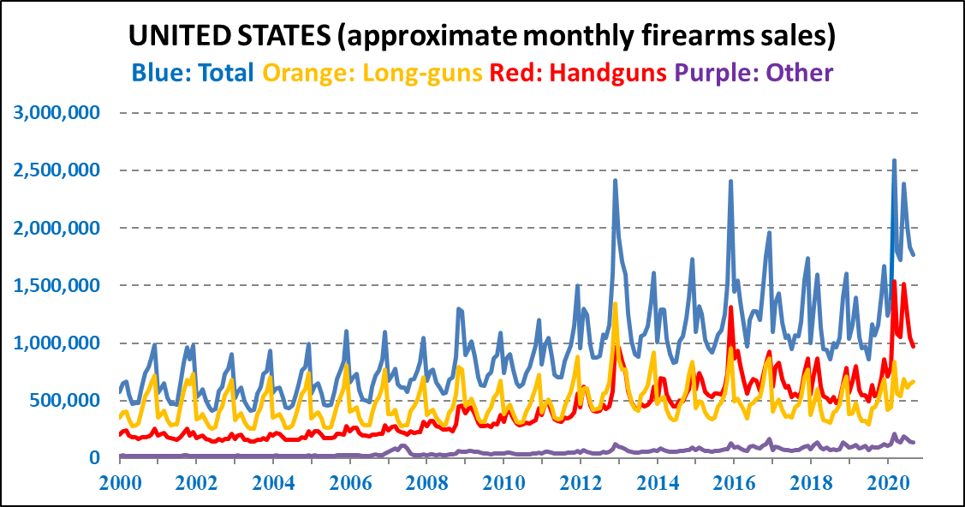
Notes: Apart from obvious seasonality effects during the year, three massive demand spikes occurred in December 2013, December 2016, and as from March 2020 during the covid-19 crisis. Likely handgun unit
sales overtook likely long-gun unit sales as from the year 2014.
CHART 2
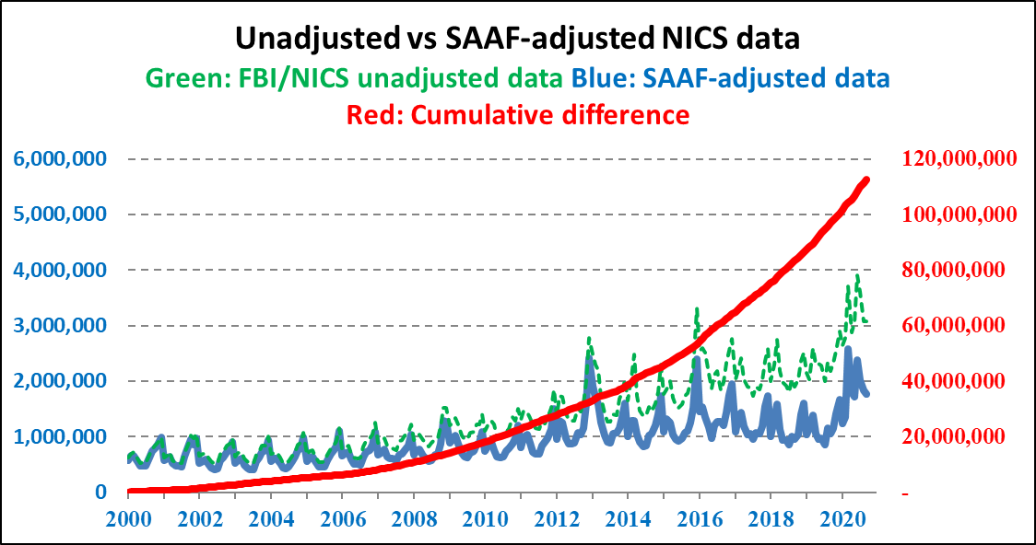
Notes: The FBI/NICS unadjusted raw data are increasingly misleading as indicators of firearms demand.
The FBI itself cautions not to equate its numbers with unit sales, hence the need for data adjustment. The cumulate difference between the unadjusted and adjusted numbers reaches a count of over 110 million.

