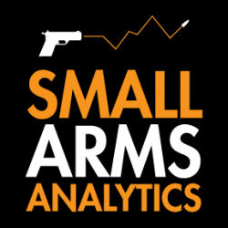
Editors: Small Arms Analytics & Forecasting’s Chief Economist Jurgen Brauer is available for interviews. Contact: jbrauer@SmallArmsAnalytics.com.
For Immediate Release, December 1, 2020
U.S. firearms sales in November: Still booming, but less so

(GREENVILLE, SC, USA & HALIFAX, NS, CANADA) – Small Arms Analytics & Forecasting (SAAF) estimates November 2020 U.S. firearms unit sales at 2.1 million units, a year-over-year increase of 49% from November 2019.
Detailed data by firearms type and state are available for purchase at https://SmallArmsAnalytics.com/shop/.
SAAF’s firearms unit sales estimates are based on raw data taken from the FBI’s National Instant Criminal Background Check System (NICS), adjusted for checks unlikely to be related to end-user firearms sales. For example, the FBI’s raw numbers (for November, some 3,602,296) cannot be taken at face value as large numbers of background checks are unrelated to end-user sales. As a case in point, in November the state of Illinois conducted about 500,000 so-called permit checks and rechecks alone whereas end-user unit sales at firearms retailers likely amounted to about 56,000. SAAF makes certain other adjustments to the data based on retailer reports and other information; nonetheless, the estimates still likely understate the true number of sales.
SAAF Chief Economist Jurgen Brauer comments that “while November 2020 continues the year’s record-breaking pace – now standing at well over 20 million units – this month’s 49% year-over-year increase is by far the smallest such monthly increase since March this year.”
-30-
Media contact: Corinne MacLellan <media@SmallArmsAnalytics.com>
Charts attached:
- Approximate United States Firearms Sales (January 2000 to November 2020).
- Unadjusted FBI/NICS raw data versus SAAF-adjusted NICS data (January 2000 to November 2020).
Follow us on Twitter | Instagram | Facebook
ABOUT Small Arms Analytics & Forecasting
Small Arms Analytics & Forecasting (SAAF) is a research consultancy focusing on the business & economics of the global small arms and ammunition markets. Politically unaffiliated, SAAF is an independent, evidenced-based resource for industry, advocacy, research, and policymaking alike, as well as for financial analysts and members of the media. Among other services, SAAF produces forecasts of U.S. civilian firearms unit sales, nationwide and for most states. Small Arms AnalyticsSM and Small Arms Analytics & ForecastingSM are legally protected Service Marks of Small Arms Analytics & Forecasting. (Contact sales@SmallArmsAnalytics.com for sales and other information.)
CHART 1
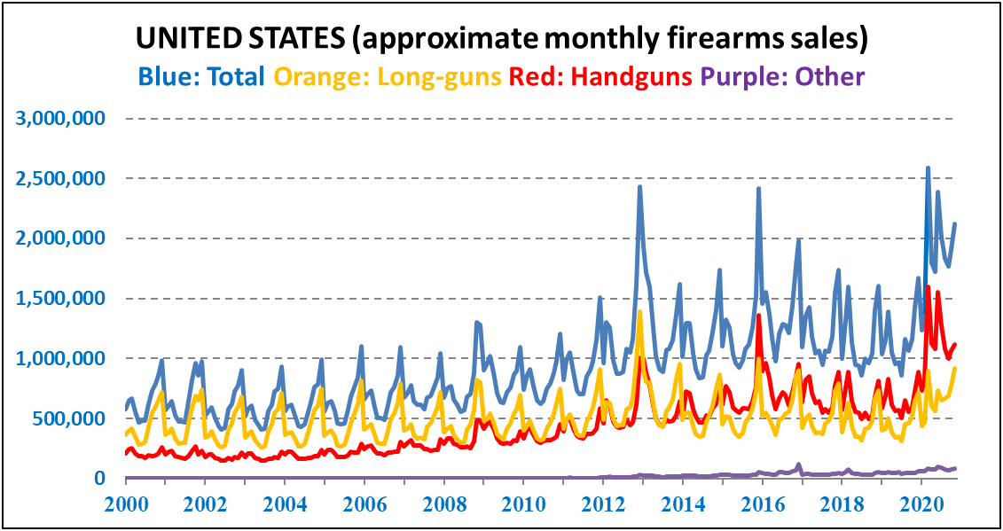
Notes: Apart from obvious seasonal effects during the year, three massive demand spikes occurred in December 2013, December 2016, and as from March 2020 during the covid-19 crisis. Likely handgun unit sales overtook likely long-gun unit sales as from the year 2014.
CHART 2
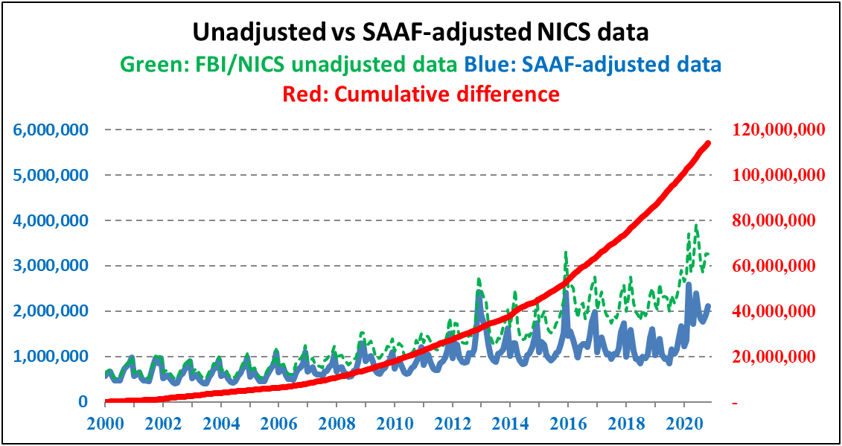
Notes: The FBI/NICS unadjusted raw data are increasingly misleading as indicators of firearms demand. The FBI itself cautions not to equate its numbers with unit sales, hence the need for data adjustment. The cumulate difference between the unadjusted and adjusted numbers reaches a count of well over 110 million.

