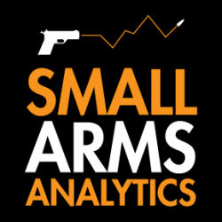
Editors: For Immediate Release, July 1, 2022 | Contact: jbrauer@SmallArmsAnalytics.com
We no longer take media interview requests but respond to emailed questions as best we can.
U.S. firearms sales June 2022: At +7.7%, June saw this year’s first year-over-year unit sales increase

(GREENVILLE, SC, USA & HALIFAX, NS, CANADA) – Small Arms Analytics & Forecasting (SAAF) estimates June 2022 U.S. firearms unit sales at about 1.5 million units, a year-over-year increase of 7.7% relative to June 2021. The increase affected the handgun segment (+5.2%) somewhat less than it did the long-gun segment (+8.9%). Still, handguns outsold long-guns by a factor of 1.71 handguns per long-gun. Detailed data by firearms type and state are available for purchase at https://SmallArmsAnalytics.com/shop/ as are firearms demand forecasts, 12 months ahead. The average forecast error over the last three months was 5.8% and over the past 12 months 0%.
SAAF’s firearms unit sales estimates and forecasts are based on raw data taken from the FBI’s National Instant Criminal Background Check System (NICS), adjusted for checks unlikely to be related to end-user firearms sales. For example, in June the state of Illinois conducted about 280,000 firearms permit checks alone whereas end-user unit sales likely amounted to about 37,000. SAAF thus makes certain adjustments to the FBI’s raw data based on retailer reports and other information. Even so, SAAF-adjusted NICS numbers may still underestimate the actual unit sales level by some amount.
SAAF Chief Economist Jurgen Brauer comments that “the June 2022 data are of interest in that they reflect this calendar year’s first year-over-year increase in firearms unit sales. This increase possibly was due to the discussion regarding additional federal firearms legislation that some customers may have viewed as detrimental to their interests even as the industry as a whole has been not wholly unsupportive of the final bill signed into law by President Biden.”
-30-
Follow us on Twitter | Facebook | Instagram
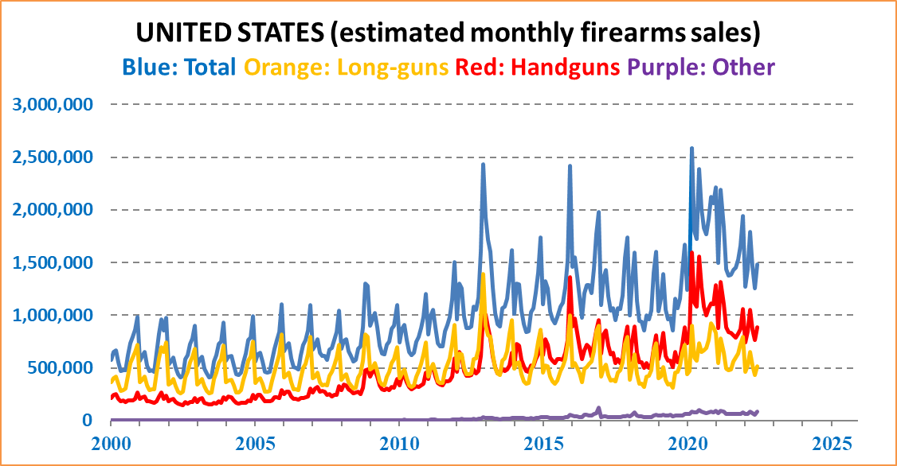
ABOUT Small Arms Analytics & Forecasting – Small Arms Analytics & Forecasting (SAAF) is a research consultancy focusing on the business & economics of the global small arms and ammunition markets. Politically unaffiliated, SAAF is an independent, evidenced-based resource for industry, advocacy, research, and policymaking alike, as well as for financial analysts and members of the media. Small Arms AnalyticsSM and Small Arms Analytics & ForecastingSM are legally protected Service Marks of Small Arms Analytics & Forecasting.
(Contact sales@SmallArmsAnalytics.com for sales and other information.)

