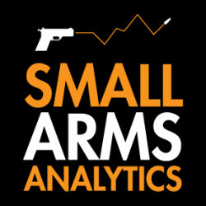
Editors: For Immediate Release, August 1, 2022 | Contact: jbrauer@SmallArmsAnalytics.com Give us your deadline, and we will respond to specific emailed questions as best we can.
U.S. firearms sales July 2022: This year’s downward adjustment continues

(GREENVILLE, SC, USA & HALIFAX, NS, CANADA) – Small Arms Analytics & Forecasting (SAAF) estimates July 2022 U.S. firearms unit sales at about 1.3 million units, a year-over-year decrease of 5.0% relative to July 2021. The decrease affected the handgun segment (−4.6%) less than it did the long-gun segment (−7.4%). In July 2022, handguns outsold long-guns by a factor of 1.77 handguns per long-gun. Detailed data are available for purchase at https://SmallArmsAnalytics.com/shop/ as are firearms demand forecasts, 12 months ahead. (The average forecast error for the last three months was 3.9% and for the past 12 months just 0.7%.)
SAAF’s firearms unit sales estimates and forecasts are based on raw data taken from the FBI’s National Instant Criminal Background Check System (NICS), adjusted for checks unlikely to be related to end-user firearms sales. For example, in July the state of Illinois conducted about 295,000 firearms permit checks alone whereas end-user unit sales likely amounted to about 35,000. SAAF thus makes certain adjustments to the FBI’s raw data based on retailer reports and other information. Even so, SAAF-adjusted NICS numbers may still underestimate the actual unit sales level by some amount.
SAAF Chief Economist Jurgen Brauer comments that “apart from June 2022 numbers, the July 2022 data continue this calendar year’s overall year-over-year decrease in firearms unit sales. Nonetheless the contrast to prior years is remarkable, with total (estimated) unit sales from January to July of 7.4 million in 2019, 13.1 million in 2020, 11.9 million in 2021, and 10.0 million thus far in 2022.”
-30-
Follow us on Twitter | Facebook | Instagram
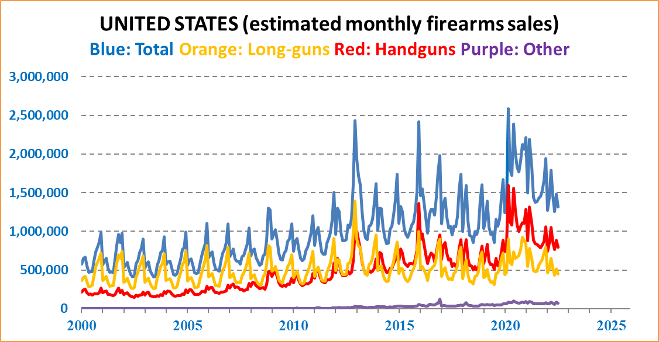
ABOUT Small Arms Analytics & Forecasting – Small Arms Analytics & Forecasting (SAAF) is a research consultancy focusing on the business & economics of the global small arms and ammunition markets. Politically unaffiliated, SAAF is an independent, evidenced-based resource for industry, advocacy, research, and policymaking alike, as well as for financial analysts and members of the media. Small Arms AnalyticsSM and Small Arms Analytics & ForecastingSM are legally protected Service Marks of Small Arms Analytics & Forecasting.
(Contact sales@SmallArmsAnalytics.com for sales and other information.)

