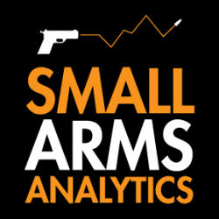
Editors: For Immediate Release, Sept. 1, 2022 | Contact: jbrauer@SmallArmsAnalytics.com Give us your deadline, and we will respond to specific emailed questions as best we can.
U.S. firearms sales August 2022: Normal “August bump” disappears for third year in a row

(GREENVILLE, SC, USA & HALIFAX, NS, CANADA) – Small Arms Analytics & Forecasting (SAAF) estimates August 2022 U.S. firearms unit sales at about 1.4 million units, a year-over-year decrease of 3.8% relative to August 2021. The decrease affected the handgun segment (−2.7%) much less than it did the long-gun segment (−7.2%). Detailed data are available for purchase at https://SmallArmsAnalytics.com/shop/ as are firearms demand forecasts, 12 months ahead. (Our average forecast error over the last three months was 3.0% and over the past 12 months just 0.5%.)
SAAF’s firearms unit sales estimates and forecasts are based on raw data taken from the FBI’s National Instant Criminal Background Check System (NICS), adjusted for checks unlikely to be related to end-user firearms sales. For example, in August the state of Illinois conducted about 347,000 firearms permit checks alone whereas end-user unit sales likely amounted to about 37,000. SAAF thus makes certain adjustments to the FBI’s raw data based on retailer reports and other information. Even so, SAAF-adjusted NICS numbers may still underestimate the actual unit sales level by some amount.
SAAF Chief Economist Jurgen Brauer comments that “normally August sales are ‘bumped up’ relative to July sales by about 10% to 30%, but this has not been the case for the past three years, possibly reflecting different purchasing patterns since covid-19 arrived in the U.S.”
-30-
Follow us on Twitter | Facebook | Instagram
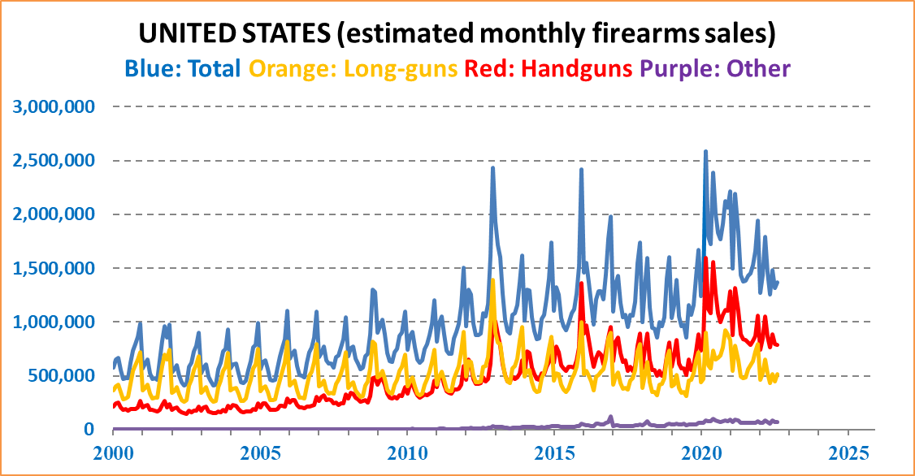
ABOUT Small Arms Analytics & Forecasting – Small Arms Analytics & Forecasting (SAAF) is a research consultancy focusing on the business & economics of the global small arms and ammunition markets. Politically unaffiliated, SAAF is an independent, evidenced-based resource for industry, advocacy, research, and policymaking alike, as well as for financial analysts and members of the media. Small Arms AnalyticsSM and Small Arms Analytics & ForecastingSM are legally protected Service Marks of Small Arms Analytics & Forecasting.
(Contact sales@SmallArmsAnalytics.com for sales and other information.)

