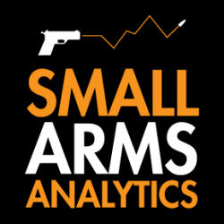
Editors: For Immediate Release, Oct. 4, 2022 | Contact jbrauer@SmallArmsAnalytics.com with
your deadline, and we will respond to specific emailed questions as best we can.
U.S. firearms sales September 2022: Down from the 2020 peak but still significantly up from 2019

(GREENVILLE, SC, USA & HALIFAX, NS, CANADA) – Small Arms Analytics & Forecasting (SAAF) estimates September 2022 U.S. firearms unit sales at about 1.3 million units, a year-over-year decrease of 8.9% relative to September 2021. The decrease affected the handgun segment (−6.4%) much less than it did the long-gun segment (−12.3%). Detailed data are available at https://SmallArmsAnalytics.com/shop/ as are firearms demand forecasts, 12 months ahead. (Our average forecast error over the last three months, July to September, was 0.7% and over the past 12 months, Oct. 2021 to Sept. 2022, 1.5%.)
SAAF’s firearms unit sales estimates and forecasts are based on raw data taken from the FBI’s National Instant Criminal Background Check System (NICS), adjusted for checks unlikely to be related to end-user firearms sales. For example, in September the state of Illinois conducted about 337,000 firearms permit checks alone whereas end-user unit sales likely amounted to about 37,000. SAAF thus makes certain adjustments to the FBI’s raw data based on retailer reports and other information. Even so, SAAF-adjusted NICS numbers may still underestimate the actual unit sales level by some amount.
SAAF Chief Economist Jurgen Brauer comments that “the estimated sales through September 2022 amounted to about 12.7 million units, about 2.1 million units off the 2021 pace and about 4 million units less than in 2020 but still significantly higher than the 9.7 million units recorded in 2019 (all for January through September of the respective years). The unit sales drop thus far this year is largest in the Midwest states and least so in the West.”
-30-
Follow us on Twitter | Facebook | Instagram
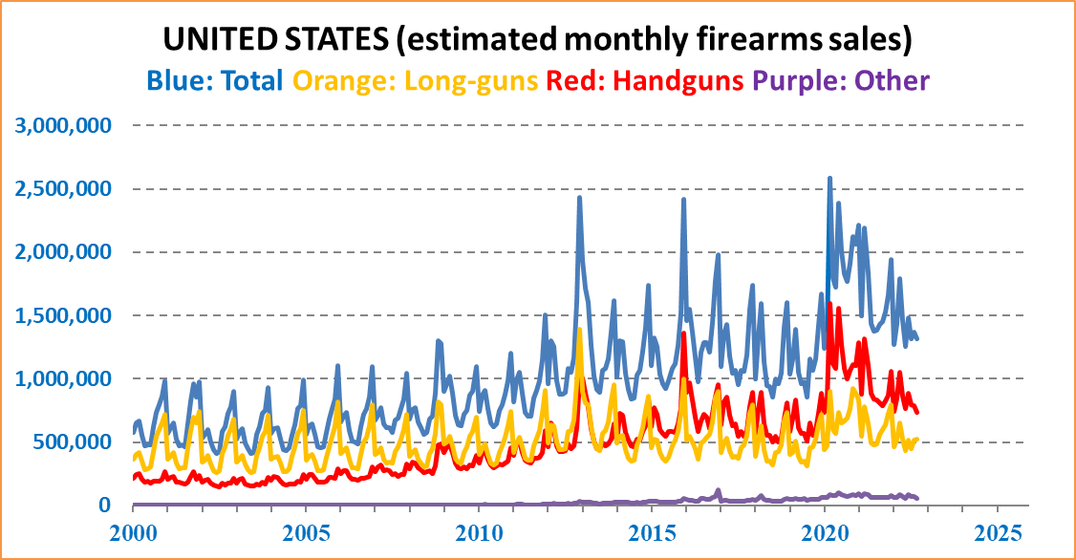
ABOUT Small Arms Analytics & Forecasting – Small Arms Analytics & Forecasting (SAAF) is a research consultancy focusing on the business & economics of the global small arms and ammunition markets. Politically unaffiliated, SAAF is an independent, evidenced-based resource for industry, advocacy, research, and policymaking alike, as well as for financial analysts and members of the media. Small Arms AnalyticsSM and Small Arms Analytics & ForecastingSM are legally protected Service Marks of Small Arms Analytics & Forecasting.
(Contact sales@SmallArmsAnalytics.com for sales and other information.)

