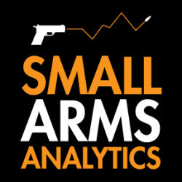
Editors: For Immediate Release, Nov. 4, 2022 | Contact jbrauer@SmallArmsAnalytics.com with your deadline and we will respond to specific emailed questions as best we can.
U.S. firearms sales October 2022: 12% year-over-year decline, per capita sales on target to equal the 2016 level

(GREENVILLE, SC, USA & HALIFAX, NS, CANADA) – Small Arms Analytics & Forecasting (SAAF) estimates October 2022 U.S. firearms unit sales at about 1.3 million units, a year-over-year decrease of 11.9% relative to October 2021. The decrease affected the handgun segment (−10.2%) less than it did the long-gun segment (−14.1%). Detailed data are available at https://SmallArmsAnalytics.com/shop/ as are firearms demand forecasts, 12 months ahead. (Our average forecast error over the last three months, August to October, was 2.7% and over the past 12 months, November 2021 to October 2022, 1.9%.)
SAAF’s firearms unit sales estimates and forecasts are based on raw data taken from the FBI’s National Instant Criminal Background Check System (NICS), adjusted for checks unlikely to be related to end-user firearms sales. For example, in October the state of Illinois conducted about 370,000 firearms permit checks alone whereas end-user unit sales likely amounted to about 37,000. SAAF thus makes certain adjustments to the FBI’s raw data based on retailer reports and other information. Even so, SAAF-adjusted NICS numbers may still underestimate the actual unit sales level by some amount.
SAAF Chief Economist Jurgen Brauer comments that “with two more months to go before year-end, this calendar year’s total unit sales are expected to come in at somewhat less than 18 million units, the highest ever save for the 2020 and 2021 covid-19 pandemic years. In terms of firearms purchases adjusted for U.S. population growth, however, this would about match the per capita level for 2016.”
-30-
Follow us on Twitter | Facebook | Instagram
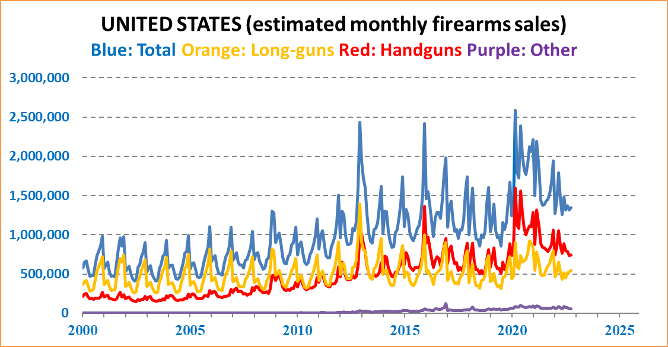
ABOUT Small Arms Analytics & Forecasting – Small Arms Analytics & Forecasting (SAAF) is a research consultancy focusing on the business & economics of the global small arms and ammunition markets. Politically unaffiliated, SAAF is an independent, evidenced-based resource for industry, advocacy, research, and policymaking alike, as well as for financial analysts and members of the media. Small Arms AnalyticsSM and Small Arms Analytics & ForecastingSM are legally protected Service Marks of Small Arms Analytics & Forecasting.
(Contact sales@SmallArmsAnalytics.com for sales and other information.)

