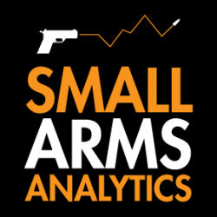
Editors: For Immediate Release, December 1st, 2022.
U.S. firearms sales November 2022: muted 1.7% year-over-year decline; long-gun sales suffered whereas handgun sales did well

(GREENVILLE, SC, USA & HALIFAX, NS, CANADA) – Small Arms Analytics & Forecasting (SAAF) estimates November 2022 U.S. firearms unit sales at about 1.6 million units, a year-over-year decrease of 1.7% relative to November 2021. Whereas the long-gun market segment fell by 5.2%, the handgun segment increased by 1.4%.
SAAF’s firearms unit sales estimates and forecasts are based on raw data taken from the FBI’s National Instant Criminal Background Check System (NICS), adjusted for checks unlikely to be related to end-user firearms sales. For example, in November the state of Illinois conducted about 412,000 firearms permit checks alone whereas end-user unit sales likely amounted to about 45,000. SAAF thus makes certain adjustments to the FBI’s raw data based on retailer reports and other information. Even so, SAAF-adjusted NICS numbers may still underestimate the actual unit sales level by some amount.
In other news, as two of its four principal partners are well into their retirement years, SAAF announces a rearrangement of its operations. Effective immediately, SAAF will be led solely by its current CEO, Thomas McGuire who may be reached at info@SmallArmsAnalytics.com. Existing customers of SAAF data subscription services will continue to receive data by direct email until their current subscriptions expire. Existing customers of custom research likewise will see their projects completed. Industry-related data purchase-by-download options will be removed from the company’s website and interest in firearms-related custom research, including data-related research, should be directed to Mr. McGuire at info@SmallArmsAnalytics.com.
-30-
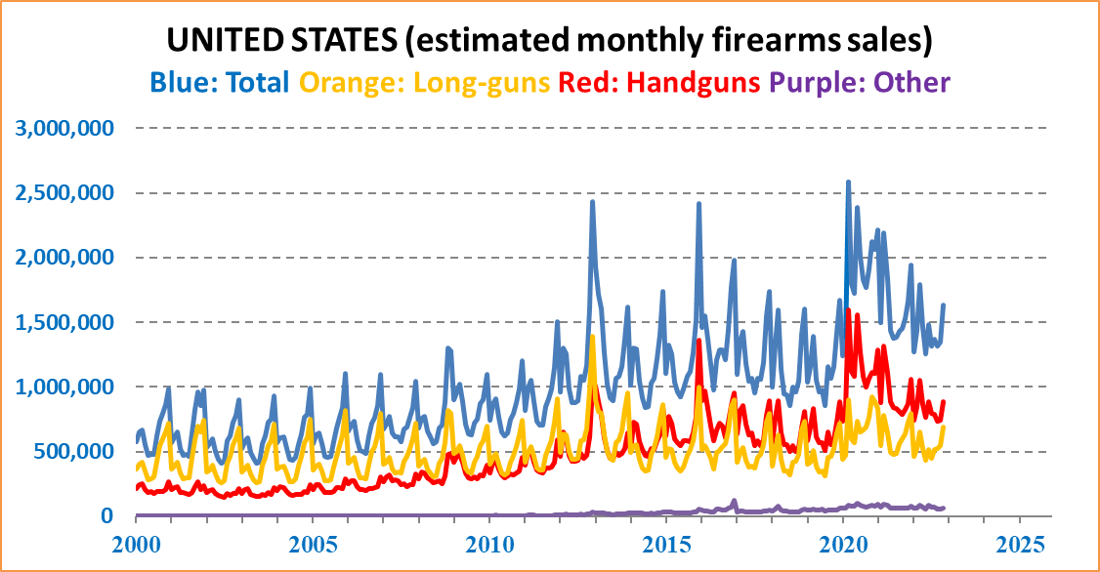
ABOUT Small Arms Analytics & Forecasting – Small Arms Analytics & Forecasting (SAAF) is a research consultancy focusing on the business & economics of the global small arms and ammunition markets. Politically unaffiliated, SAAF is an independent, evidenced-based resource for industry, advocacy, research, and policymaking alike, as well as for financial analysts and members of the media. Small Arms AnalyticsSM and Small Arms Analytics & ForecastingSM are legally protected Service Marks of Small Arms Analytics & Forecasting.

